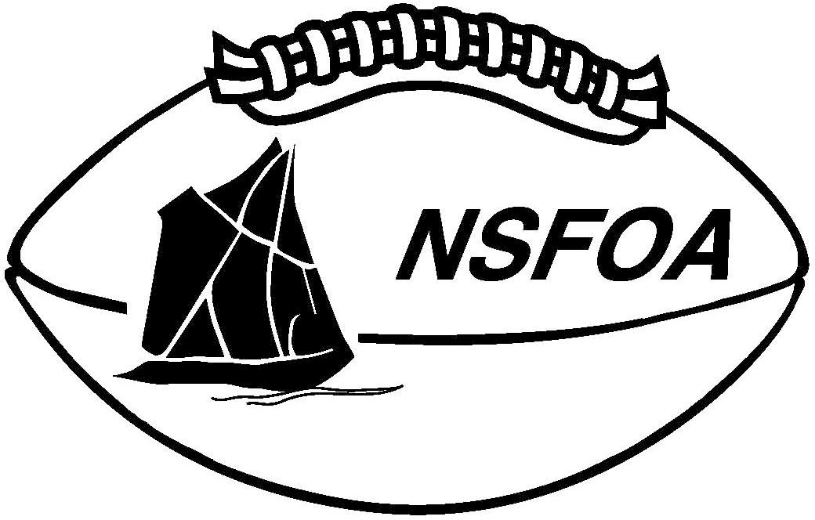
Nova Scotia Football Officials’ Association

REFEREE GAME REPORT

Game #
Game Date: League:
Location:

Home Team: Visitors:

Referee:

Umpire:

Down Judge:

Line Judge:

Side Judge:

Back Judge:

Back Umpire:

Back Judge:

Field Judge:

Timer:

Driver:

Driver 2:

Game Details(Issues, incidents, Fines):

